1. **Authentication**(I)
   1. It implements Principal (i)
      1. It is from Java Security API. From Core Java.
   2. **Methods**:
      1. getDetails():
         1. IP Address of the user trying to log in.
      2. isAuthenticated():
         1. Default value is false.
      3. But when user is authenticated, it is set to true by calling the method Authentication.setAuthenticated(Boolean)
   3. This object is very important object used by Spring Security.
   4. This object contains all the required info about a user before authentication and after authentication.
   5. 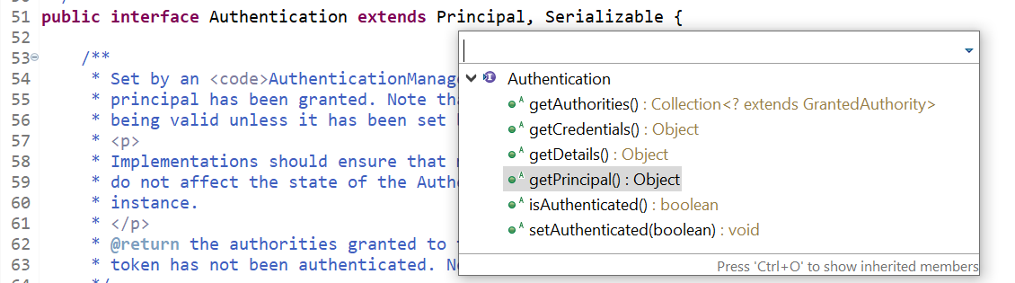
2. 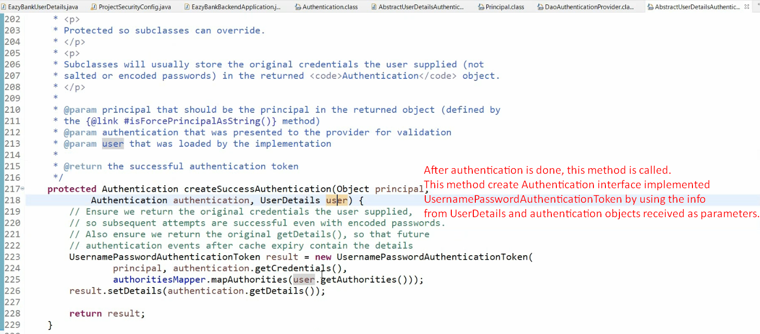
3. **NOTE**: From **AuthenticationFilter**, Authentication object is passed and then on return a new Authentication Object is returned.
4. **Question:** Why two different objects Authentication and UserDetails to maintain the same info means about user info.
5. **Answer:**
   1. Spring Security gives you flexibility at different layers.
   2. Such as on Filter, you maintain user info in Authentication whereas on AuthenticationProvider layer, in the form of UserDetails.
   3. **NOTE**: If you want to use Authentication Object in UserDetailsService also, you can give your own AuthenticationProvider.